**DAILY ONLINE ACTIVITIES SUMMARY**

|  |  |  |  |  |  |  |  |  |
| --- | --- | --- | --- | --- | --- | --- | --- | --- |
| **Date:** | **04/07/2020** | | | | | **Name:** | **NIKHIL KUMAR** | |
| **Sem & Sec** | **4thSEM. & ‘B’ SEC.** | | | | | **USN:** | **4AL19CS400** | |
| **Online Test Summary** | | | | | | | | |
| **Subject** | | **NULL** | | | | | | |
| **Max. Marks** | | **30** | | **Score** | | |  | |
| **Certification Course Summary** | | | | | | | | |
| **Course** | **Built your own chatbot** | | | | | | | |
| **Certificate Provider** | | | **Cognitiveclass** | | **Duration** | | | **1 week** |
| **Coding Challenges** | | | | | | | | |
| **Problem Statement1 :** Given an array of integer arr[] and an integer k, the task is to find the median of each window of size k starting from the left and moving towards the right by one position each time.  Examples: Input: arr[] = {-1, 5, 13, 8, 2, 3, 3, 1}, k = 3 Output: 5 8 8 3 3 3 Input: arr[] = {-1, 5, 13, 8, 2, 3, 3, 1}, k = 4 Output: 6.5 6.5 5.5 3.0 2.5 | | | | | | | | |
| **Status: Executed** | | | | | | | | |
| **Uploaded the report in Github** | | | | | **Yes** | | | |
| **If yes Repository name** | | | | | 1. <https://github.com/Nikhil401/java-coding/blob/master/Median.java> | | | |
| **Uploaded the report in slack** | | | | | **Yes** | | | |

**Online Test Summary : Not conducted**

**Certification Course Summary: Today I went through the module4 : defining a dialog which includes ”putting it all together, building user friendly chat-bot, lab6, lab7 with quiz”.**

**Snapshot is given below 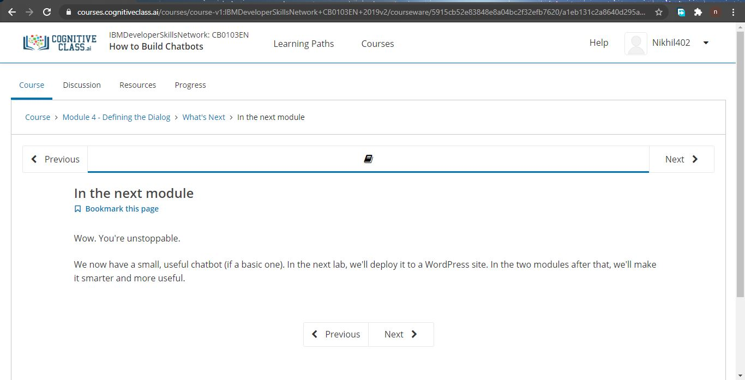Online Training : There were conducted talk webinar series on advanced IT requirements for the future Engineers from 10 am to 11 am by Almuni Mr. Aditya Naik, Site core developer, Veltech, Bangalore…..**

**Online coding summary: Today I had received programs which is mentioned in table above and I have uploaded into the github repository. Snapshot of the program is given below:**

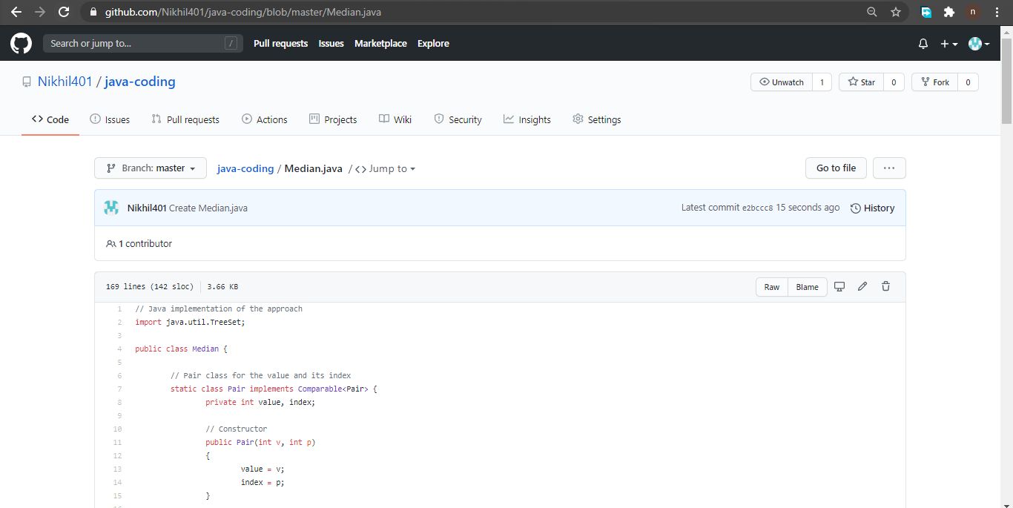 **Thank you.**